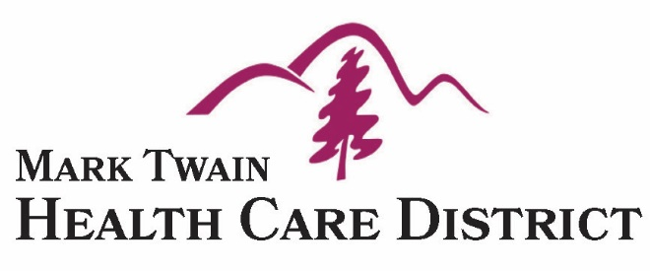
P. O. Box 95
San Andreas, CA 95249
(209) 754-4468 Telephone
(209) 754-2537 Fax

April 12, 2018

To:

Dear Community Grants Applicant,

Thank you for applying for one of the Mark Twain Health Care District grants.
This year we had numerous applications for very exciting and worthy projects.
The District was not able to fund every request. One of the exclusionary factors was salaries, as the District does not grant money for salaries or wages.
Your application was very appreciated and will be funded partially or in full. We really appreciate the important work you do in our county.
I would also like to inform you that the District will consider future out-of-cycle requests for time sensitive and emergency funding. The District Board meets on the fourth Wednesday of every month in the Education Center at the Mark Twain Medical Center at 7:30 am.
Please join the Board at their meeting on April 25 at 10am to be recognized.
Again, thank you for your great contribution to Calaveras County.
Cordially,

Randy Smart MD
Executive Director
Mark Twain Health Care District

Mark Twain Health Care District Mission Statement
“Through community collaboration, we serve as the stewards of a community health system that ensures our residents have the dignity of access to care that provides high quality, professional and compassionate health care”.

Common Ground Senior Services
229 New York Ranch Rd,
Jackson, CA 95642
$10,000.00

Friends of the Calaveras County Fair
P O Box 489
Angels Camp Ca 95222
$2,400.00

Calaveras County Seniors’ Center, Inc
P O Box 1526
San Andreas, CA 95249
$4,000.00

Mind Matters
150 Big Trees Rd (Suite D)
Murphys, CA 95247
$ 1,605.00

Murphys Senior Center
65 Mitchler Ave
Murphys, CA 95247
$ 8,920.00

Blue Mountain Coalition for Youth & Families
P O Box 41
West Point, CA 95255
2,500.00

Sierra HOPE
P O Box 159
Angels Camp, CA 95222
$12,500.00

